**MT “19X_Dis” Disintegration of Tablets**

**Scope**

This method is intended for measuring the completeness of the disintegration of tablets independent of the use rate. The method is designed for, but not limited to the disintegration of effervescent tablets.

**Outline of method**

One entire tablet is added to a defined volume of CIPAC standard water D and mixed by gentle stirring for the specified disintegration time of the tablet. The suspension is then passed through a 2000 μm sieve. The absence of a residue on the screen indicates complete disintegration of the tablet.

The method should only be used with tablets that are designed to disintegrate completely and disperse in water prior to application. In the case of tablets of large size an adaptation of the method may be necessary (Note 1).

**Reagents**

*CIPAC standard water D*., MT 18.1.4, unless otherwise specified

*Water*, deionised

**Apparatus**

*Beaker* 2000 ml with a diameter of 130 ± 2 mm (short)

*Stirrer motor* with speed control

*Stainless steel stirrer* propeller type with four fixed stirrer blades set at an angle of 45°, shaft length: 350 mm, propeller diameter: 50 mm, blade width: 10 mm (see Fig. 1).

*Thermometer*

*Sieve*, 2000 µm, 200 mm diameter, ISO 565 or equivalent

*Analytical balance,* with an accuracy of ± 1 mg

*Glass* *dish*

*Dryer, with temperature control*

*Desiccator*

**Procedure**

Fill the beaker with 1800 ml of CIPAC standard water D which has a temperature of 25 ± 5°C. The stirrer should be centrally located in the beaker and is positioned in such a way that the bottom of the stirrer blades is about 30 mm (Note 2) above the bottom of the beaker. The pitch of the stirrer blades and the direction of rotation are such that the propeller pushes the water upwards. Weigh the tablet to the nearest 0.01 g (w in [g]). Switch on the stirrer with the speed set to 300 ± 10 rpm (Note 3). Add the tablet to the water and stir for the time specified by the manufacturer (Note 4).

Note the stirring time. Switch off, remove the stirrer, rinse it briefly with deionised water and immediately transfer the content of the beaker onto the 2000 µm sieve. Rinse the beaker and the sieve briefly with deionised water. Check if there is any residue ≥ 2000 µm on the sieve. If present, transfer any residue to a glass dish which is weighed to the nearest 1 mg (a in [g]) with a jet of deionised water. Dry to constant weight (Note 5) and record the weight of the glass dish to the nearest 1 mg (b in [g]).

**Calculation**



a = mass of the glass dish [g]

b = mass of the glass dish and residue [g]

w = mass of the tablet added [g]

Note 1 The tablet should not be broken or cut. An adaptation of water volume and stirrer (size, type, speed and position) is appropriate. Modifications need to be reported.

Note 2 The position of the stirrer plates should be adapted to a distance of more than 30 mm if the diameter of the tablet exceeds 30 mm.

Note 3: The stirrer speed should be decreased if the tablet breaks by impact of the stirrer plates.

Note 4 The stirring time has to be specified by the manufacturer of the tablet. If the stirring time is not specified by the manufacturer of the tablet, then stir for 10 minutes.

Note 5 A temperature of 60 – 70 °C is recommended. If necessary, the temperature must be adapted to avoid decomposition or volatilisation of formulation components at the drying temperature.

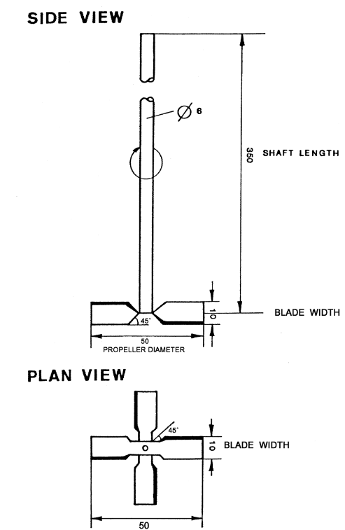

*Figure 1* Propeller type stirrer ((mm) units of linear measure)